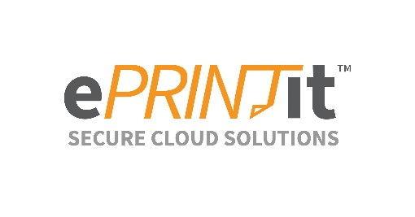
Print from Anywhere/Mobile Printing Service
Use your phone or personal device to send prints to the library printer via web, email or mobile app. Pick up at the library.  Prints are available for only 24 hours and when the library is open. | Cost:  $0.10 per page, Black & White  $0.25 per page, Color

Upload via Web

To send a print job via the Web:

- Visit https://castleshannon.eprintitsaas.com/public/upload
- Select Files to Print
- Choose options (number of copies, color, etc.)
- Enter your name or library card number
- SUBMIT
- Visit the <Circulation Desk>, pay, and pick up your prints.

Send via Email
Black & White: bw-castleshannon@eprintitsaas.com
Color: color-castleshannon@eprintitsaas.com

To print an email message and attachment via Email:

- Start a new email and attach the files you want to print, or locate the file you want to print, and send via email using the share/send function.
- Send the email to the Black & White or Color printer email address (see box above).

Note: the body of the email and all attachments will be sent as separate print jobs. You can choose which you want to print before you pay.

You will received release instructions by email that can be used to retrieve your printouts.


Send via Mobile App

Download the ePrintit Saas app from your device’s app store

